**Analyzing HR Dataset using Power BI**

The HR dataset I explored was gotten from kaggle.com. the dataset was a comprehensive one as it contained various components of what constitute an employee status in an organization.

I used the Microsoft Power BI application to come up with my analysis.

The dataset contained *thirty (36) columns* and *ten thousand, nine hundred and eighty-one rows.*

**Power BI Query Editor**

The data itself was clean. I had to duplicate the dataset to have it retain its original features. On the duplicated data, I removed some columns like: marriedid, genderid, empstatusid, deptid, perfscoreid etc. I then used delimiter to remove (,) from the name column. The replace value was used to make the column “TermResaon” readable.

**Power BI Interface**

Here, I used DAX – Data Analysis Expressions to create Columns and Measures.

* **Column**s

The following columns were added to the table:

1. Age: this was derived by subtracting the date of birth from the date of hire.
2. Age Band: this shows the group on of the employees. It was done using the “IF Function”.
3. Year of hire: gotten from the hire date. It shows the various year employees were hired.

* **Measures**

The following measures were created

1. Total Employee
2. Active employee
3. Active female employee
4. Active male employee
5. Average age
6. Average income
7. Exited employee
8. Active female employee (%)
9. Active male employee
10. Number of terminated employee
11. Termination rate
12. Voluntary exit
13. Voluntary turnover rate
14. Turnover rate

**Visualization**

Here, I brought charts and cards to create 2 reports (i) Employee Overview (ii) Exit Analysis (iii) Turnover Analysis

* **Employee Overview**

On this report page, I used

* Cards to show employee, active employee, active male (%), active female (%), exited employee, average (avg) age, average (avg) income, terminated, voluntary exit.
* Bar charts to show active employee by age band, active employee by Department, active employee by recruitment source, active employee by marital status.
* Table to show the top five (5) highest earners

The visual is shown below.

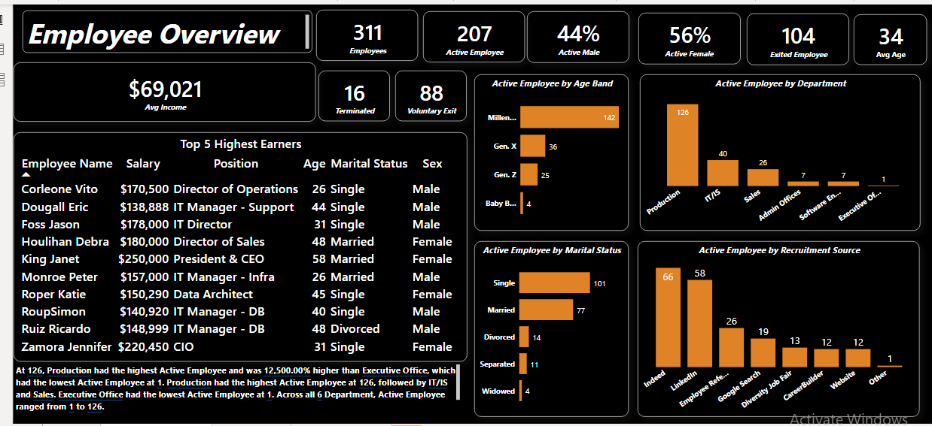

* Exit Analysis

Here, I made use of

* Cards to show exited employee, voluntary exit and terminated employee
* Bar charts to show exited employee by sex, exited employee by marital status, exited employee by department, exited employee by recruitment source, exited employee by age band.

The visual is seen below

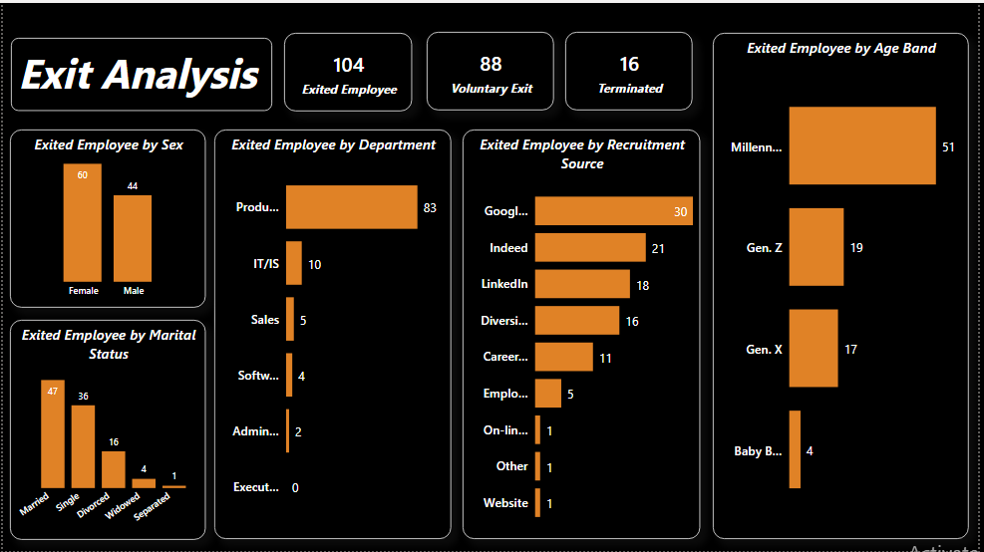

* Turnover Analysis
* Cards were used to show turnover rate, voluntary turnover, termination rate.
* Bar charts to show termination rate and voluntary turnover by age band, turnover rate by position, voluntary turnover and termination rate by marital status, voluntary turnover and termination by sex.
* Matrix table to show turnover rate by department

Here is the visual

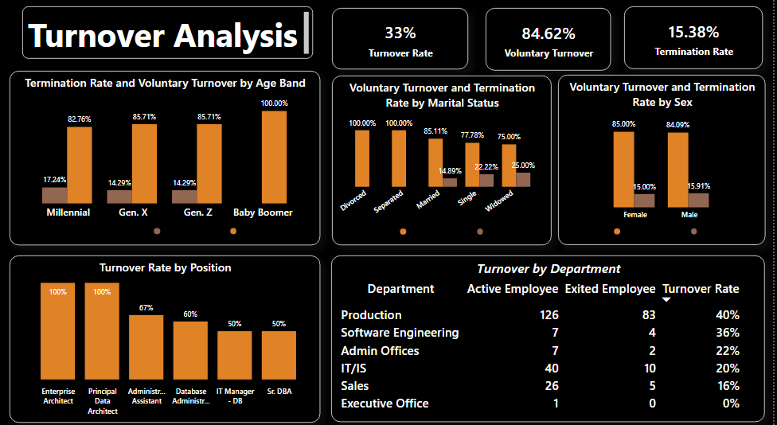

**Insights**

1. There was a total al of 311 employees and 104 exited leaving the active employees to be 207.
2. Most of the active employees are in the Millennial age (19-25years).
3. Across the 8 Recruitment Source, INDEED was the most engaged followed by LinkedIn.
4. More of female gender exited the organization compare to their male counterparts.
5. There was higher rate of voluntarily exit that termination.

**Recommendations**

1. For Gender Balance, more female gender should be recruited.
2. The organization should have a comprehensive review of their policies due to the high rate of voluntary exit.
3. More persons should be employed in the Production Department noting that it is the most affected department by exit.
4. The Organization should focus more on Recruiting from both Indeed and [LinkedIn](https://www.linkedin.com/company/linkedin/) since applicants from these job search sites stays longer.
5. The organization should look into the remuneration package, career growth, Personal Development, attitude of superiors to subordinates so as to retain those within the Millennials and Generation X age group as they are the future of the organization.